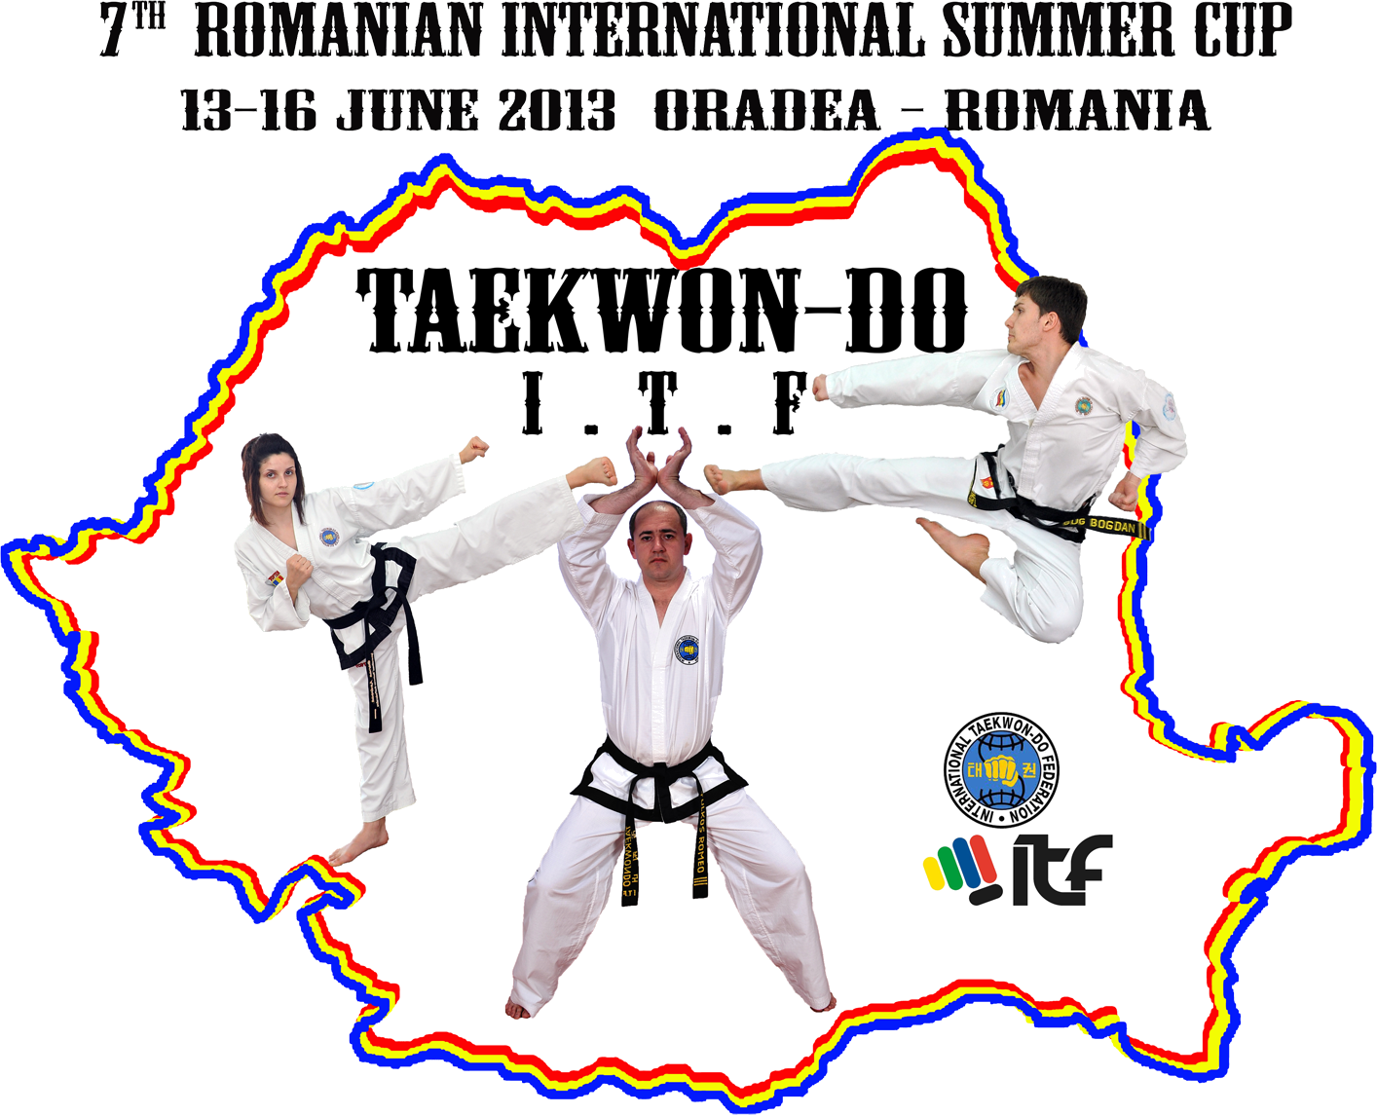
GUEST OF HONOR:
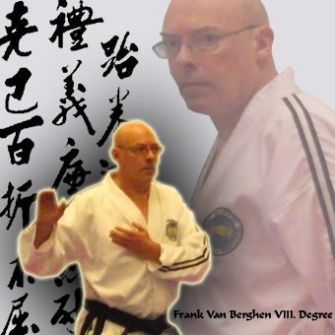

Master Frank Vanberghen – VIII DAN
_________________________________________________________

INVITATION

Romanian Taekwon-do ITF Federation
Taekwon-do Club KING DO-LIONS ORADEA and
Taekwon-do Club ROYAL KWON ORADEA in collaboration with
Youth and Sport County Direction Bihor are pleased to invite you to
INTERNATIONAL SUMMER CUP 7TH EDITION

- General Information
Period and place: 13 – 16 June 2013, Oradea, Romania.
Sporthall: ANTONIO ALEXE ORADEA Arena, 3 Cazaban Street, Oradea, 410272 Bihor County.
Terms of participation: Can participate all organizations from Europe (clubs or federations) affiliated to A.E.T.F. or I.T.F.
Registration: fill the registration forms from the site www.taekwondo-itf.ro and sent them to e-mail: mmvali@yahoo.com until 03 June 2013 (including). Competition entry, schedules checking and fees payments will be made Thursday 13th June 2013 in the lobby of the Continental Forum**** Hotel Oradea City (1 Strandului street) between hours 14,00-19,00 (local time).
Changes: any changes of the registration forms made after the registration deadline (03 June 2013, 23:59 hour), will be charged with 5 EURO/each change (except for the competitors withdrawal).

The Organization Board:

President: Local Organizer:
Mr. Mircea Muntean – VI DAN Mr.Tulkos Romeo – IV DAN
Secretary General of Romanian Taekwon-do I.T.F. Federation President of King do-Lions, Taekwon-do Club Oradea
Email : mmvali@yahoo.com Email : romi_kingdo@yahoo.com
mobil: 0040 -721 823 410 mobil: 0040-743 347 685

Local Co-Organizer:
Mr.Tripa Francisc – IV DAN
President of Royal Kwon Taekwon-do Club Oradea
mobil: 0040-746 796590
.
VIEW OF ARENA ANTONIO ALEXE ORADEA, 3 Cazaban street
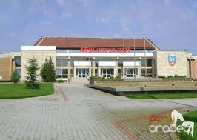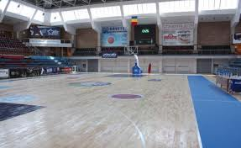
2. Fees
A. The participation only to individual pattern and sparring: 10 EURO/competitor (in euro). Participation to individual special techniques and/or power test must add 5 EURO/competitor (in euro);
B. The participation fee/team: 20 EURO (in euro) – a single payment for all the events, separately for each team – kids, juniors, seniors, male, female;
C. Umpires fee: (will be 150 EURO - in euro) represents a warranty for arbitration and will be reimbursed to the clubs after the end of the competition. The attending clubs must provide: 1 umpire/club for clubs that have between 1 and 10 competitors, 2 umpires/club for clubs that have between 11 and 20 competitors, and 3 umpires/club for clubs that have over 20 competitors. Clubs without umpires will not get this fee back. If the clubs they don’t have the required number of umpires, will be retained 50 euro for each referee missed. Accommodation from all umpires is paid by the organizer during the competition period (13-16 June), and is made in one of the places announced at registration day in 13 June. The Organization board also provides free lunch (drinks not included) for each umpire during the competition days.
3. Schedule of the competition:
Thursday- 13 June 2013:
Arrival to the accommodation place, Continental Forum**** Hotel Oradea City (1 Strandului street) before 17.00 (local hour). The Accommodation confirmations will be sent until 3th of June 2013 at e-mail: romi_kingdo@yahoo.com. After this date the Organization Board has no responsibility for booking.
12.00 Press Conference;
14.00 – 19.00 Registrations in the hotel Hall;
19.30 - 20.30 Umpires meeting will take place in the Hall of Continental Forum Hotel of Oradea; The Umpires will be dressed in umpire suit according to the I.T.F. Umpire Rules.
20.30- 21.30 Technical Meeting for draw will take place in the Hall of Continental Forum Hotel of Oradea: 1 coach/each club is convoked. Team whose coach not participated at technical meeting will be penalized with an amount of € 25 will be withdrawn from umpires fee.
Friday 14 june 2013:
08.00- 08.15 - arrival to the sport hall;
08.30- 13.00 – competition/ awarding ceremony;
13.00 - 14.45 – lunch break;
14.45 - 15.00 – arrival to the sport hall;
15.00 - 20.30 - competition/ award ceremony

Saturaday 15 june 2013:
08.00- 08.15 - arrival to the sport hall;
08.30- 13.00 – competition/ awarding ceremony;
13.00 - 14.45 - lunch break;
14.45 - 15.00 - arrival to the sport hall;
15.00 - 19.00 – competition;
19.00 - 19.45 Opening Ceremony:
Guests of Honor: Master Frank Vanberghen – 8 DAN and Mrs. Annick Van Driessche – 6 Dan
19:45 – 21:45 finals individual seniors (pattern and sparring)

Sunday 16 june 2013
09.00 - 09.15 - arrival to the sport hall;
09.30 – 14.30 - competition/ awarding ceremony;
14.30 - 16.00 - lunch break;
16.00 - 16.30 - arrival to the sport hall;
16.30 - 20.00 - competition/ awarding ceremony;
20.00 - 20.30 – Closing ceremony.

Competition Rules: for juniors III, II, I and seniors, the competition and umpire rules is on ITF and Romanian Taekwon-do ITF Federation rules. For all competitors who take part in sparring section is required helmet wearing colored corner at which the athlete competes.

4. Coaches and Umpires
Coaches:
a) Must wear sport clothing and carry a towel on the sparring area;
b) One single coach will be present on the sparring area.
Umpires:
Local Organizer will pay for all umpires accommodation starting Thursday 13 June 2013, 12.00 p.m. until Monday 17 June 2013 11,00 a.m.
The umpires must attend to the Umpires Meeting on Thursday 13 June 2013, 19.30 p.m. in the Hall of the Continental Forum Hotel of Oradea. Those who are not present to the Umpire Meeting will be excluded from the umpires list and they lose the accommodation, and the arbitration fee will not be reimbursed to the clubs to which these umpires are registered.

5. Contest events and division: competitors number - 4 competitors/category, and the lowest rank required is 8 Gup (yellow belt).
Juniors III şi II (kids):
- Individual pattern - (male and female): - 6 years; -8 years; -10 years; -12 years; -14 years;
- Team pattern - (male and female): -14 years;
- Individual sparring (male and female): - 6 years; -8 years;
- Individual sparring (8-10 years) Male: -33 kg; -40 kg; +40 kg;
Female: -30 kg; -35 kg; +35 kg;
- Individual sparring (10-12 years) Male: -35 kg; -45 kg; -55 kg; +55 kg;
Female: -35 kg; -45 kg; +45 kg;
- Individual sparring (12 -14 years) Male: -40 kg; -48 kg; -56 kg; +56 kg;
Female: -35 kg; -42 kg; -50 kg; +50 kg;
- Individual special techniques, two divisions: 10-12 years and 12-14 years, male and female; (only Twimyo nopi ap cha busigi and Twimyo nopi yop cha jirugi)

Juniors I (14 – 18 years):
  - Individual pattern - (male and female): colored belts, I DAN, II DAN;
  - Team pattern - (male and female): only junior competitors, no kids allowed;
  - Individual sparring male: -50 kg; -56 kg; -62 kg; -68 kg; -75 kg; + 75 kg;
  - Individual sparring female: -45 kg; -50 kg; -55 kg; -60 kg; -65 kg; + 65 kg;
  - Team sparring- male and female: minimum 3 junior competitors, maximum 5 + 1- all junior competitors, no kids allowed;
  - Individual power test - male and female: no kids allowed;
  - Team power test - male and female: (minimum 3 junior competitors, maximum 5 + 1- all junior competitors, no kids allowed);
  - Individual special techniques - male and female: no kids allowed;
  - Team special techniques - male and female: (minimum 3 junior competitors, maximum 5 + 1- all junior competitors, no kids allowed);
  - Traditional Sparring: (minimum 2 Gup required from each member of team; the team can be mixed, only juniors; THE FEE IS NOT PAID SEPARATELY FOR THIS DIVISION).
Seniors (18 – 35 years):
  - Individual pattern - male and female: colored belts, I DAN, II DAN, III DAN and IV-VI DAN;
  - Team pattern - male and female: senior competitors, is allowed to add maximum 2 juniors with 17 years fulfilled besides three seniors;
  - Individual sparring male: -57 kg; -63 kg; -70 kg; -78 kg; -85 kg; +85 kg;
  - Individual sparring female: -50 kg; -56 kg; -62 kg; -68 kg; -75 kg; +75 kg;
  - Team sparring - male and female: minimum 3 senior competitors, maximum 5+1- competitors; is allowed to add maximum 2 juniors with 17 years fulfilled besides three seniors;
  - Individual power test - male and female: no juniors allowed;
  - Team power test - male and female: minimum 3 senior competitors, maximum 5+1 competitors; is allowed to add maximum 2 juniors with 17 years fulfilled besides three seniors;
  - Individual special techniques - male and female: no juniors allowed;
  - Team special techniques - male and female: minimum 3 senior competitors, maximum 5+1 competitors; is allowed to add maximum 2 juniors with 17 years fulfilled besides three seniors;
  - Traditional Sparring: (minimum 1 Dan required from each member of team; the team can be mixed, only seniors; THE FEE IS NOT PAID SEPARATELY FOR THIS DIVISION).
  - Old boys sparring: from male competitors between 35-45 years (old boys), on the following categories: -65 kg; 66-75 kg, 76-85 kg and +85 kg.
HEIGHTS AND NUMBER OF BOARDS TO SPECIAL TECHNIQUES AND POWER TEST
MALE SPECIAL TECHNIQUES
 | JUNIORS | SENIORS
FEMALE SPECIAL TECHNIQUES
TWIMYO NOPI AP CHA BUSIGI | 250 cm | 260 cm
TWIMYO DOLLYO CHAGI | 230 cm | 240 cm
TWIMYO BANDAE DOLLYO CHAGI | 210 cm | 220 cm
TWIMYO DOLMYO YOP CHA JIRUGI | 210 cm | 220 cm
TWIMYO NOPI YOP CHA JIRUGI | 130 cm | 140 cm
 | JUNIORS | SENIORS
TWIMYO NOPI AP CHA BUSIGI | 210 cm | 220 cm
TWIMYO DOLLYO CHAGI | 200 cm | 210 cm
TWIMYO NOPI YOP CHA JIRUGI | 110 cm | 120 cm

MALE POWER TEST
 | JUNIORS | SENIORS
AP-JOOMUK JIRUGI | 1 | 2
SONKAL TAERIGI | 1 | 2
YOP CHA JIRUGI | 2 | 3
DOLLYO CHAGI | 2 | 3
BANDAE DOLLYO CHAGI | 1 | 2

FEMALE POWER TEST
 | JUNIORS | SENIORS
SONKAL TAERIGI | 1 | 2
YOP CHA JIRUGI | 2 | 3
DOLLYO CHAGI | 2 | 2

6. Awards
- Medals and diplomas for 1st, 2nd and 3rd place;
- Cups and diplomas for the general ranking for kids, juniors and seniors;
- Plaques and diplomas for umpires.

7.Confirmation deadlines:
- 03 JUNE (inclusive) 2013 – FOR ACCOMODATION AND REGISTRATION.

8.Accomodation: HOTEL FORUM* * * * CONTINENTAL-ORADEA:
Room 2 or 3 beds………………… 15 euro /bad (person) /night
VIEW OF HOTEL FORUM**** CONTINENTAL
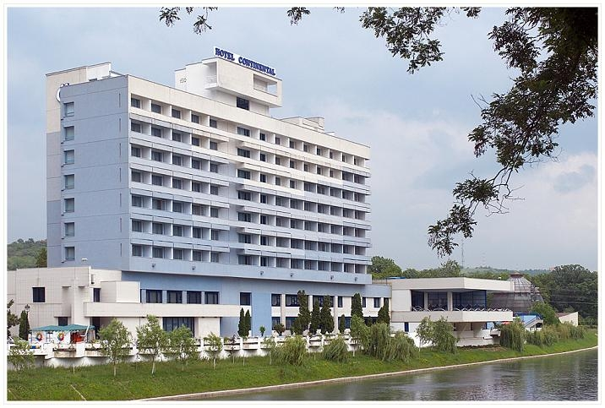
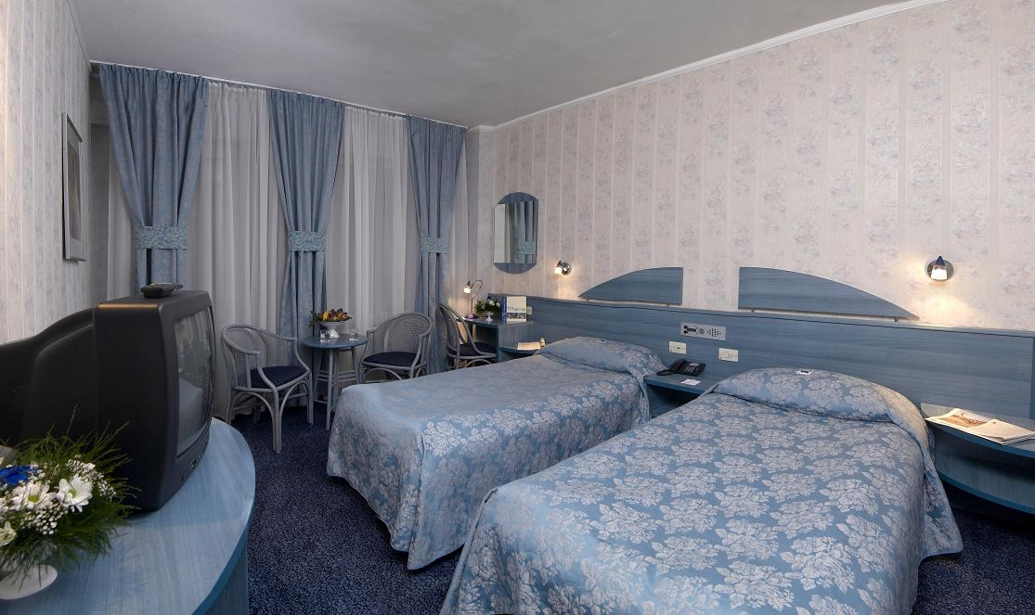 The Hotel provides:
- Guarded car parking: 10 RON (2,5 EU) / day
- Guarded parking for buses: 15 RON (4 EU) / day
- Pool : 10 RON (2,5 EU) / day / person
- At the FORUM CONTINENTAL hotel, you can have meals; the costs are set at the reception hotel upon arrival.
- Meals are served optionally and are not included in the accommodation price.

9. Other information
- During the competition in the sport hall there will be a mini bar and a stand with competition and style promotional products (t-shirts, caps, key chains etc.)..
- Sports equipment can be achieved from Top Ten stand.
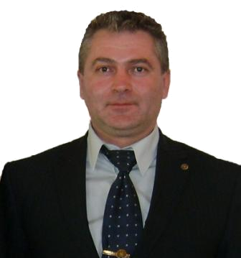
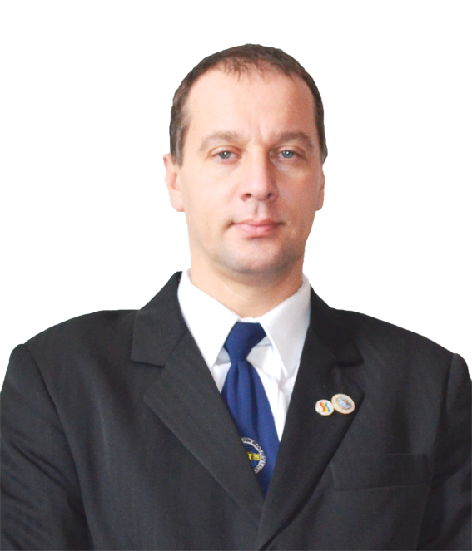

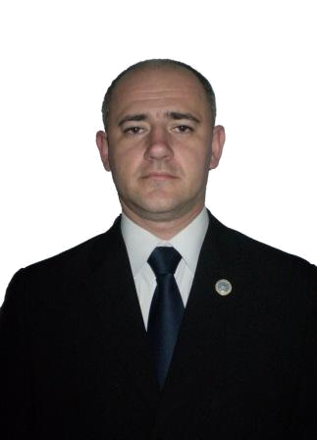
Mr. Marius Oltean – VI Dan Mr.Mircea Muntean –VI Dan
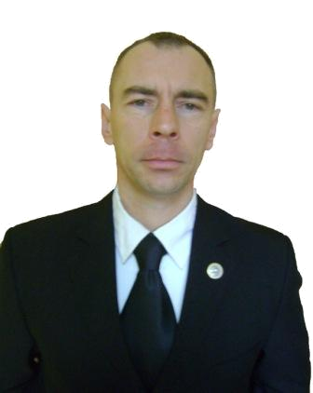
President of Secretary General of
Romanian Taekwon-do Federation

Local Organizer Local Co-organizer

Mr.Romeo Tulkos – IV Dan Mr.Tripa Francisc – IV Dan
President of President of
King –do Lions Club Royal Kwon Club

